**PROJECT REPORT TEMPLATE**

**1 INTRODUCTION**

**1.1 Overview**

An ATS is a type of software application that handles the recruitment process, namely by sorting through thousands of resumes, to determine which ones are the best fit for the positions for which they were submitted. Applicant tracking systems do not process your resume so differently from recruiters glancing at your resume, as both are looking for certain criteria for inclusion. Whereas human recruiters are often looking for grounds for automatic rejection, such as spelling errors or lack of relevant skills, applicant tracking systems operate by searching resumes for keywords.

**1.2 Purpose**

Applicant tracking systems help employers save time and paper and help them stay organized. With applicant tracking systems, there is no risk of an employer accidentally deleting the email containing the resume of the applicant the company wants to hire or misplacing a file. An ATS also makes it easy for employers to keep tabs on the hiring process and to communicate with applicants directly. Applicant tracking systems were first used by large corporations that receive thousands of applications, but smaller businesses are now using them just as frequently. Just as companies use software applications to keep track of relevant information on their customers, using similar software to organize information on prospective employees makes sense for employers.

**2 Problem Definition & Design Thinking**

2.1 Empathy Map

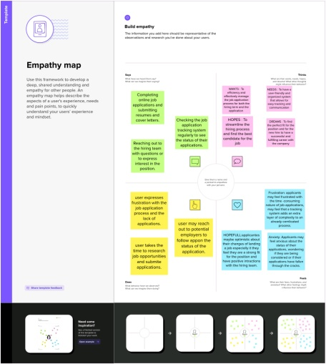

**2.2 Ideation & Brainstorming Map**

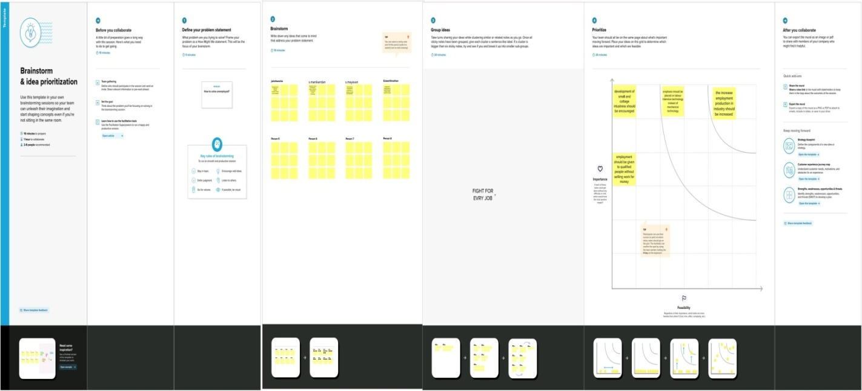

**3 RESULTS**

3.1 DATA MODEL

|  |  |
| --- | --- |
| OBJECT NAME | FIELD IN THE OBJECT |
| OBJECT 2 | |  |  | | --- | --- | | FIELD LABLE | DATA TYPE | | Job tittle | Text | |
| OBJECT 2 | |  |  | | --- | --- | | FIELD LABLE | DATA TYPE | | Recruiter | Master-detail relationship | | Description | Text Area | | Location | Text | |
| OBJECT 3 | - |
| OBJECT 4 | - |
| OBJECT 5 | - |

**3. 2 : ACTIVITY & SCREENSHORT:**

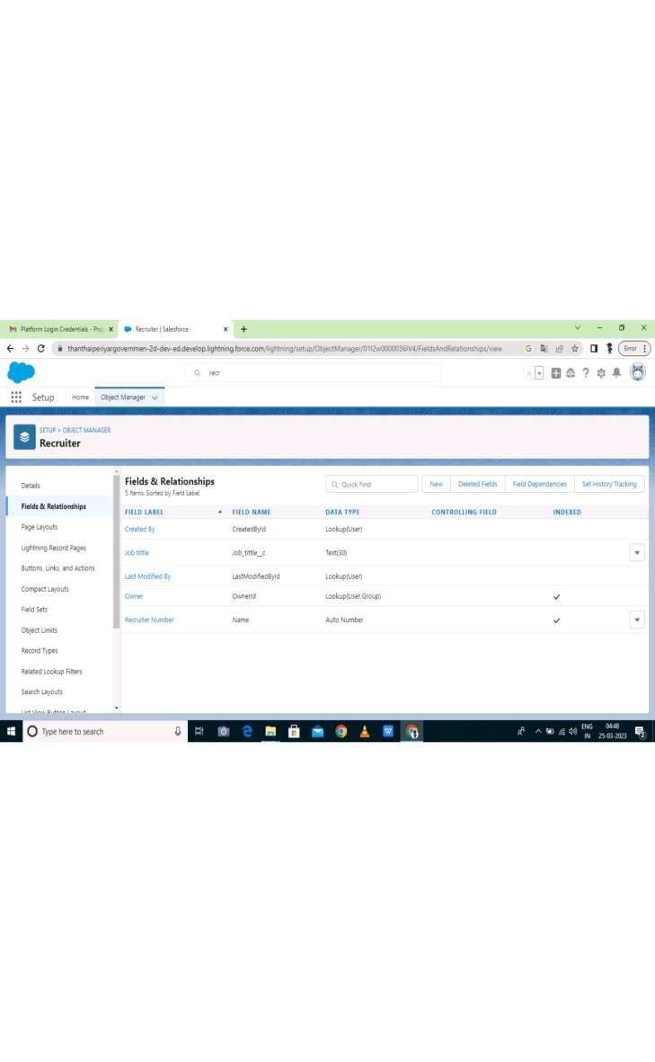 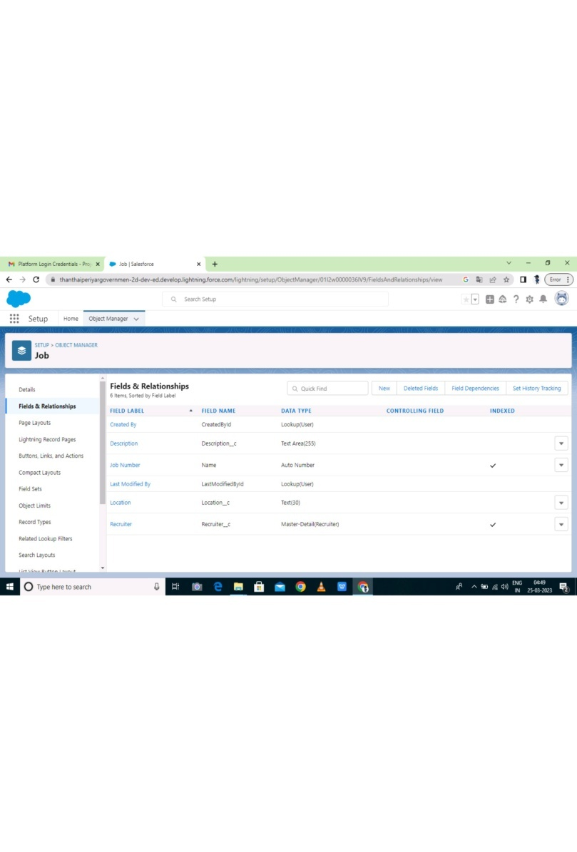

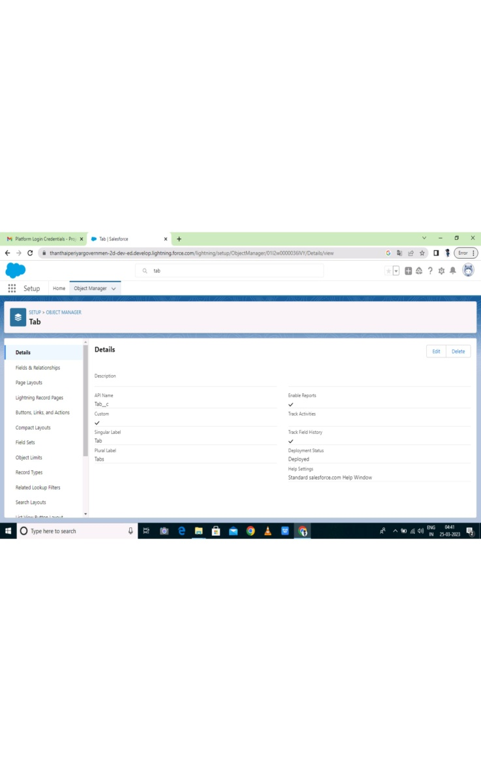 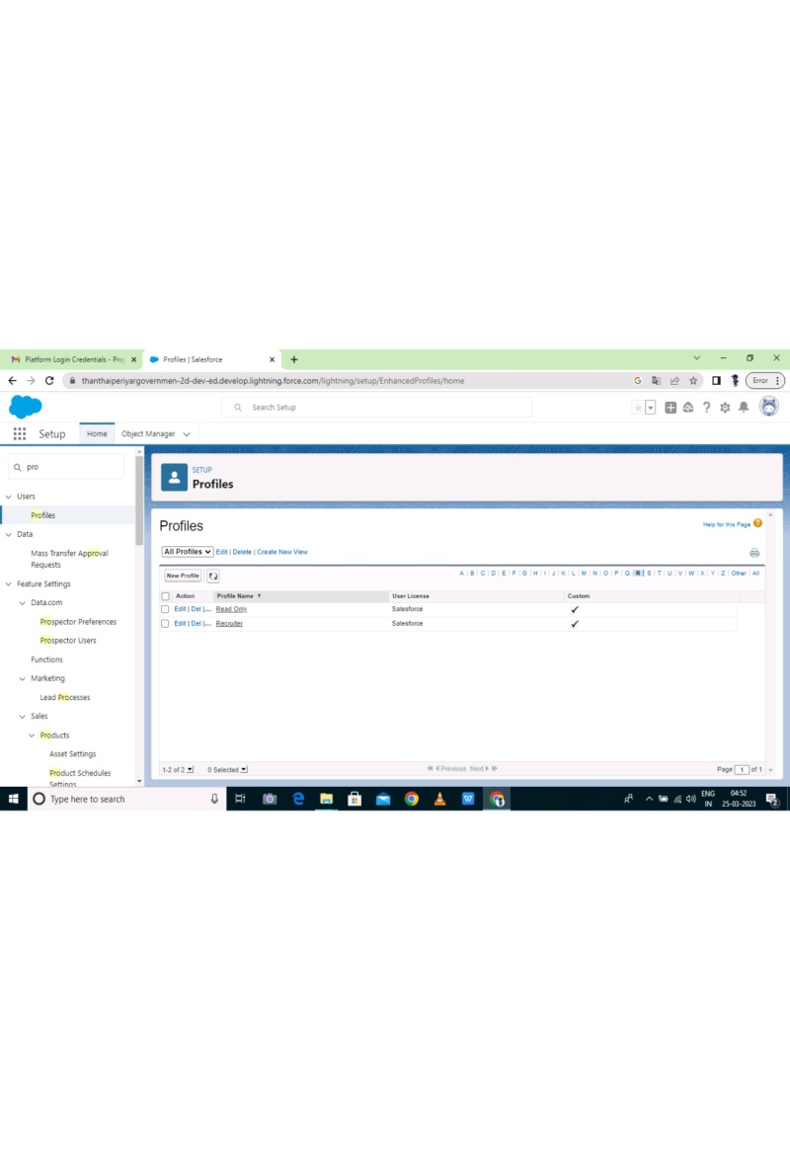

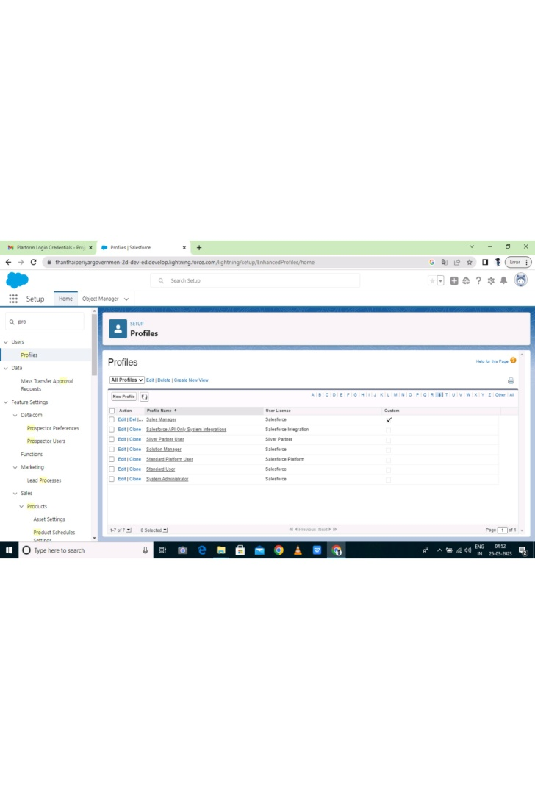 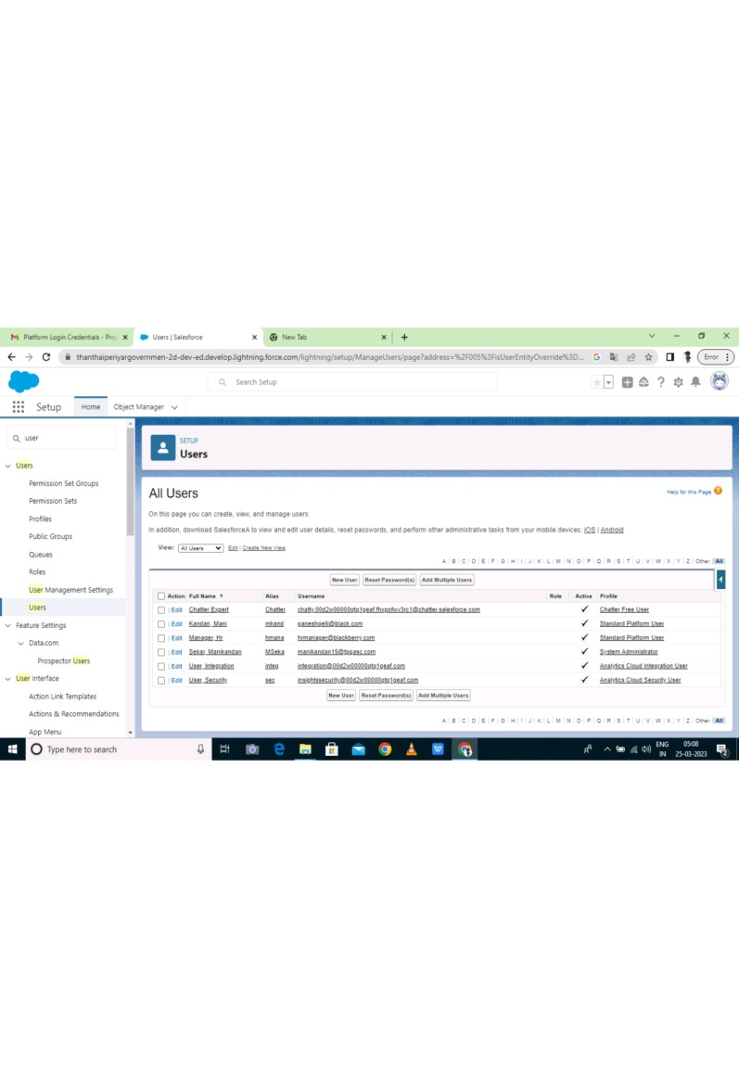

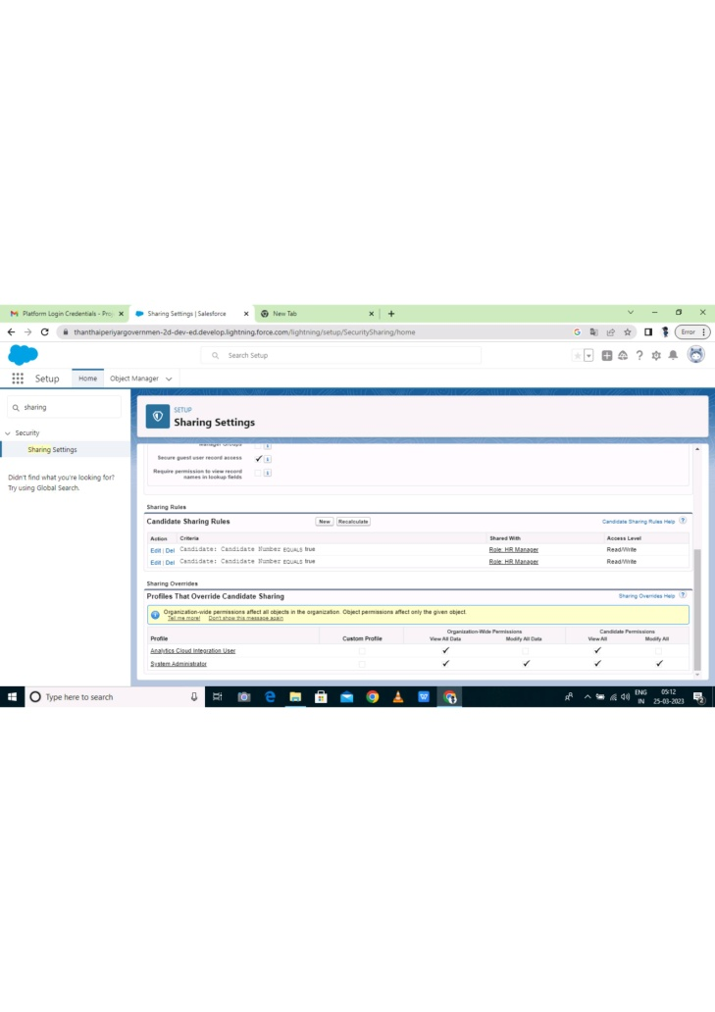 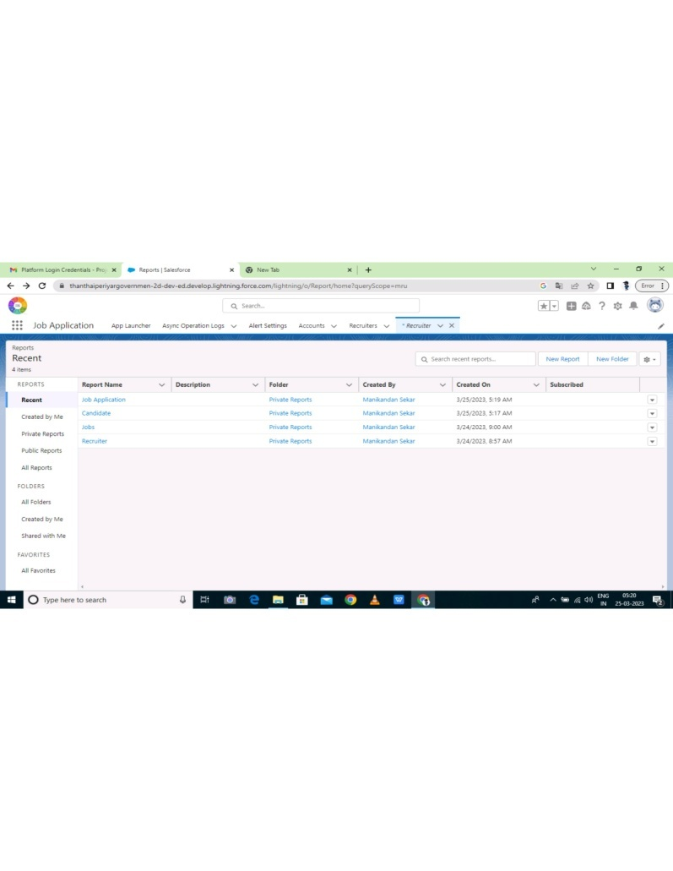

**4 Trailhead Profile Public URL**

Team Lead – <https://trailblazer.me/id/jaruldass>

Team Member 1 – <https://trailblazer.me/id/keerg22>

Team Member 2 – <https://trailblazer.me/id/msekar24>

Team Member 3 - <https://trailblazer.me/id/msivakumar10>

**5 ADVANTAGES & DISADVANTAGES**

**ADVANTAGES**

1) Reduces time spent on admin tasks

2) Resume and CV screening

3) Speeds up the recruitment cycle

4) Improves the quality of hire

5) Enhances reporting and compliance

**DISADVANTAGES**

1) Could filter out good candidates

2) Communications can be less personalized

3) Misread out on potential great hires

4) The inability to read most, if not all, graphics

5) Incorrectly categorized data from resumes that were created in an unusual format

**6 APPLICATIONS**

1) Streamlines recruiting

2) Posts jobs on multiple job boards

3) Saves time by automating mundane tasks

4) Builds your brand

5) Manages talent database

6) Promotes easy collaboration among the recruiting teams

7) Helps find the right candidates and filters out the candidates that don’t fit the role well

8) Centralizes candidate management and document tracking

9) Reduces cost per hire

10) Generates key recruiting insights

**7 CONCLUSION**

Applicant Tracking System for recruiters is a very effective hiring solution that most of the successful recruiters utilize. Because without it, there is a good chance that your process of moving applicants through different stages can become very difficult.

**8 FUTURE SCOPE**

1) Better Candidate Screening

2) Candidate Pool Available

3) An ATS Now Has Deep Integration Capabilities

4) Rise of Cloud-Based Job Applicant Tracking

5) Cost-Reductions